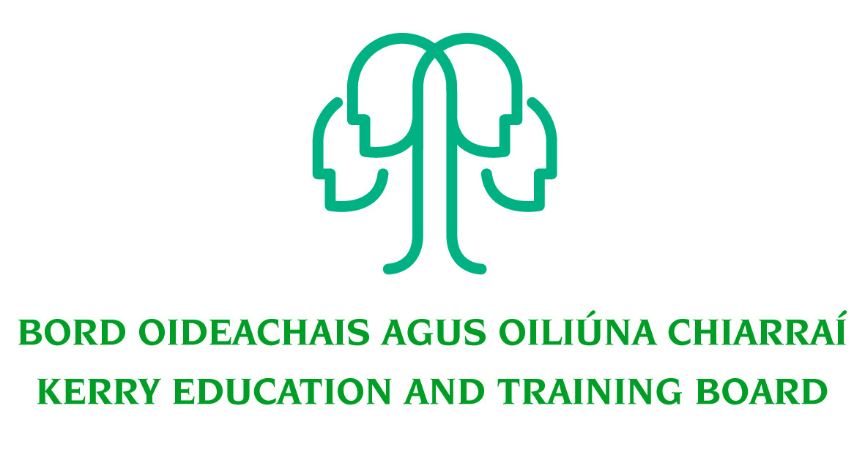
Kerry Education & Training Board wishes to recruit committed, enthusiastic and talented educators to its team of teachers and educational leaders. We provide a quality comprehensive education service in eight second level schools, four adult education centres and through a wide range of community-based adult and further education and training programmes.

Kerry ETB schools/centres are democratic, holistic in their approach, they are inclusive, cooperative and restorative in nature and prioritise the provision of quality teaching and learning. Kerry ETB encourages and supports their staff to implement evidence informed methodologies and assessment for learning. Parents and students/learners are valued partners in Kerry ETB schools/centres and their participation in decision making is supported and facilitated.

Chaplain Post – Coláiste na Sceilge, Caherciveen
Kerry Education and Training Board invites applications for the Permanent post of Chaplain to commence September, 2014 in Coláiste na Sceilge. Coláiste na Sceilge is a Community College in Trustee Partnership with the Presentation Order. The Diocese of Kerry will provide advice, guidance and support for the work of the Chaplain.

To qualify for appointment candidates must have:
- Recognised Post-Primary Teaching Qualification (Qualification in Catechetics would be an advantage)
- Qualification in School in Chaplaincy Studies/Pastoral Care or equivalent
- Registration in accordance with Section 31 of the Teaching Council Act, 2001.
- Excellent group work and interpersonal skills
- A deep commitment to KES core values: - Learning, quality, respect and inclusion

Conditions of Service, Terms of Appointment, Qualifications and Salary Scales are in accordance with the regulations of the Department of Education & Skills.
Salary: Class III Teachers Scale with Qualification Allowances.
------------------------------------------------------------------------------------------------------------------------
Applicants are requested to submit Confirmation of Teaching Council Registration outlining subjects qualified to teach and proof of current registration with their application form.
---------------------------------------------------------------------------------------------------------------------------------

Please complete application form which can be downloaded from this website www.kerryetb.ie/opportunities and return by email only to jobs@kerryetb.ie. No C.V.’s only official application form will be accepted.

Applications by email only must be received not later than 1pm on Friday 8th August 2014.

Kerry Education & Training Board services Gaeltacht areas.
Cuirfear fáilte roimh chomhfhreagras i nGaeilge.
Garda Vetting of successful candidates will take place prior to offer of employment.
Canvassing will automatically disqualify. Shortlisting of applicants may take place.

Kerry Education & Training Board is an equal opportunities employer.
“Creating a Learning Society in Kerry”

