Ballymacelligott Parish Earth Week 2010

Ballymacelligott celebrated the harvest at mass in each of the two churches St. Brendans, Clogher & Church of the Immaculate Conception, Ballymac.

Gathering in thanksgiving for the many blessings of this harvest time,
may it remind us to enjoy & respect the beauty of our countryside and all of creation as gifts of an ever loving God

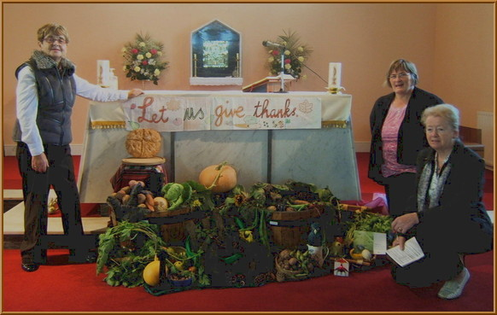
Kay, Nan & Mary and the Harvest display in Ballymacelligott.

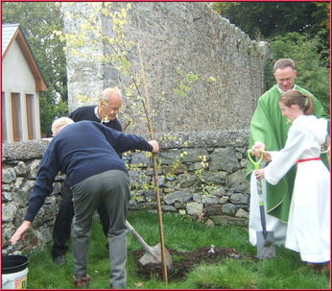

There were tree plantings at each church too.

Helping hands for the planting of the Silver Birch at Clogher.
2010 was the
Year of the Birch,
Bliain na Caithne .

A holly tree was planted in Ballymacelligott.

A Sunday afternoon walk along the Glounageenta Trail on 3 October, led by John Lenihan, was another highlight of the week.

The Parish Pastoral Council produced a leaflet ‘OUR PLANET In Trust to Us’ listing a number of interesting and relevant web sites.
This was a welcome addition to the Resource Book sent to each parish to help in the preparation of Kerry Earth Week 2010.

Parishioners from Ballymacelligott also took part in other Earth Week events taking place locally including the Biodiversity Walk on Gortbrack Organic Farm and the Bat Walk in Ballyseedy Woods.

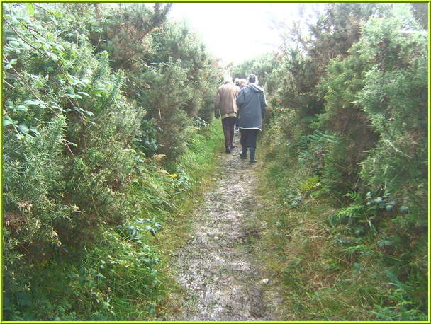
Biodiversity Farm Walk at, Gortbrack: Up the lane to the pond and the bog

Thank you to all who enabled all these events to happen- liturgy groups, choirs, those who shared their harvest, John Lenihan, the Pastoral Council, Fr Pat, Sr. Bernardine, altar servers, tree planters and all the parishioners.

