In preparation for the Feast of St Brendan 0n May 16th
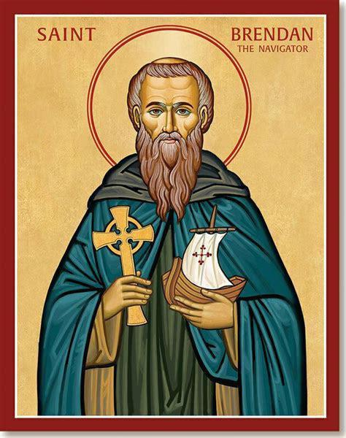
Parish Celebration at Sunday Mass [Ascension Sunday]
on Sunday May 12th
Gathering Rite
Introduction
The Lives of Bréanainn tell us of his birth and upbringing, of miracles of healing, patronage and wisdom, of voyaging and different foundations. Bréanainn was born among the Altraige, a tribe originally centred around Tralee Bay. The young Bréanainn was tutored by Erc and travelled in his youth far and near to learn the Rules of the Saints of Ireland. It has also been suggested that he travelled as far as David of Wales to learn his Rule from him. Today we remember his adventurous spirit, his passion for God and his courage to head out into the unknown.

Presentation of Symbols
[ The symbols(boat, globe and candle) are placed on a table in front of the altar]

Today, we remember our diocesan patron, St Brendan. We bring forward a boat, noting the fragility of the boat in the midst of the ocean, and the courage of those who travel the seas. St Brendan undertook his voyage hoping to find God in a deeper way, having had a vision of a secret place out in the ocean. May we be courageous in opening our hearts to God’s dream of peace and justice for the world.

We offer a globe, symbol of our world and of all the peoples of the earth. We are reminded of St Brendan’s faith and hope in God as he ventured to share the Gospel with others. May our parishes be places of welcome for all people as we share the love of God with all.

Finally, we present a candle, symbol of the light of Christ. We pray for the courage to be people of faith, that like St Brendan, we may be people who are led by Christ’s light in our daily decisions and choices.

- Penitential Rite

Liturgy of the Word
Readings of the Sunday – Ascension of the Lord
- First Reading – Acts of the Apostles 1:1-11
- Responsorial Psalm – Ps 46
- Second Reading – Ephesians 1: 17-23 or Eph 4:1-13
- Gospel – Mark 16:15-20

Prayer of the Faithful
Presider On this feast of the Ascension, let us bring our petitions before God,
confident that our prayers are always heard.
Reader
- For Pope Francis and all Church leaders - may they have the courage and commitment to reach out beyond borders to preach the gospel. Lord, hear us.
- For the clergy and people of the Diocese of Kerry navigating new horizons at this time, that we may be emboldened by St Brendan’s vision and spirit of freedom. Lord, hear us.
- For all those who find themselves far from homeland or from family – may the courage and tenacity of St. Brendan strengthen them. Lord, hear us.
- For all who traverse the seas for their livelihood, and all who take to the seas in search of a better life for themselves and their families. Lord, hear us.
- For all young people - may they embark upon life as a voyage of discovery and realise the presence of Christ within themselves and the people of their community. Lord, hear us.
- For those who have died. Lord, hear us.

Presider Heavenly Father,
we thank for our faith and the life and example of St Brendan.
Hear the prayers we now make,
in the name of Jesus, your Son, who is Lord forever and ever.
Amen.

Liturgy of the Eucharist
- Preparation of the Gifts - Instrumental traditional music to accompany the bringing of the bread and wine to the altar.

- Eucharistic Prayer – Various Needs III – Jesus, the Way to the Father

Communion Rite
Reflection after Communion
Lord, help me to journey
beyond the familiar and into the unknown
Give me the faith to leave old ways
and break fresh ground with you.
Christ of the mysteries,
I trust you to be stronger than each storm within me.
I will trust in the darkness
and know that my times,
even now, are in your hand.
Tune my spirit to the music of heaven,
and somehow, make my obedience count for you. Amen. Prayer Attributed to St. Brendan the Navigator

Homily Notes
… a “NO” stops everything; however, a “YES” branches off and opens doors and windows and possibilities and options and choices and ultimately, a “YES” loves. When that “YES” is spoken to God in fidelity, in trust, in courage, in friendship, in hope God will then take us where we need to be -- not necessarily where we want to be – but where we need to be. God will take us to our purpose, give us a vision, create in us community. Saint Brendan, like so many of the saints, was an emphatic, fearless “YES” to God. His “YES” is centre stage. In that “YES” he can hear the voice of God rolling over the rough seas crashing against the Irish coastline. God’s voice must have leapt out at him in the midst of the salty spray and grim and wet against the craggy rocks. He could hear the voice of God calling to him in the winds that rustled the leaves of trees and swayed the green grassy fields that fed flocks of sheep. God’s voice was heard, and it settled in deep. It stoked a fire within him. The vision: make a boat out of animal hid, slather it with animal fat, ask a few friends to go along, and then set sail. But this was God’s voice, a voice that won’t lead us wrong. And look where Brendan’s “YES” to God led him. He went on a journey like none other. His “YES” brought his name to Ohio where two churches are named under his patronage – one in Columbus and one in North Olmsted. If he had said “NO,” Brendan would have no real story to tell, and his name may be relegated to only pockets of family talking about him back on the Irish landscape. He never would have left the beach. Saint Brendan lived to be in his nineties. I would have loved to sit with him in his old age and prompt him to start talking about his travels, as if an Irishman needs any prompting to talk. I would start him off slow of course, but when warmed up, I would say, “Tell us about the whale.” I can imagine his white hair, his black and brown monk robe, and his deep green eyes. They must have blazed. I would then ask, “Brendan, how can I say “YES” to God?” He would settle back, close his eyes, and take in the question. Coming to his mind would be those who showed him the way like his parents, Bishop Erc, and his teacher Sister Ita. Perhaps he would even think of Patrick and Bridget and what they forged out to do before him. He would eventually break the silence with one word, “Jump.” He would smile and repeat again, “Jump. Jump in the boat with me. I’ll show you how to say “YES.” Let’s put out into deep water. The “YES” of God is there.” Going forward, let us get into the boat. Put out into deep water. Let our “YES” be deep and bold.
Adapted from www.stbrendannortholmsted.org/Downloads/Daily%20Homily%2016%20May%2020203.pdf.

Music Suggestions
Irish Airs such as Tabhair Dom do Lamh, Carolan’s Concerto, An Gaoth Aneas, An Mhaighdean Mhara could also be used as instrumental pieces.
• On the Journey - Liam Lawton
• The Servant Song
• Pilgrims of Hope
• Be Thou My Vision
• Pilgrim Alleluia – Liam Lawton
• Here I Am Lord

• You Shall Go Out with Joy – S. Dauermann
• The Brendan Voyage – Instrumental by Shaun Davey
• Keep Me Safe O God – Psalm
• Lead me Lord in Your Righteousness- Wesley
• You Shall Go Out with Joy – S. Dauermann
• The Brendan Voyage – Instrumental by Shaun Davey
• Keep Me Safe O God – Psalm
- Seek Ye First
• Lead me Lord in Your Righteousness- Wesley

Parish Mass on Thursday May 16th
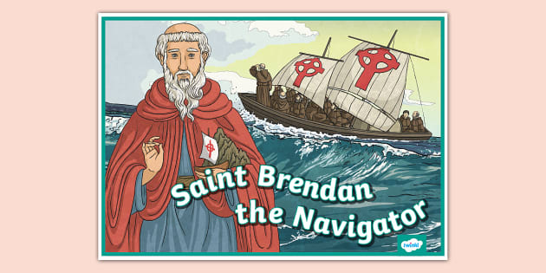

Gathering Rite
- Introduction
The Lives of Bréanainn tell us of his birth and upbringing, of miracles of healing, patronage and wisdom, of voyaging and different foundations. Bréanainn was born among the Altraige, a tribe originally centred around Tralee Bay. The young Bréanainn was tutored by Erc and travelled in his youth far and near to learn the Rules of the Saints of Ireland. It has also been suggested that he travelled as far as David of Wales to learn his Rule from him. Today we remember his adventurous spirit, his passion for God and his courage to head out into the unknown.

- Presentation of Symbols
[ The symbols(boat, globe and candle) are placed on a table in front of the altar]

Today, we remember our diocesan patron, St Brendan. We bring forward a boat, noting the fragility of the boat in the midst of the ocean, and the courage of those who travel the seas. St Brendan undertook his voyage hoping to find God in a deeper way, having had a vision of a secret place out in the ocean. May we be courageous in opening our hearts to God’s dream of peace and justice for the world.

We offer a globe, symbol of our world and of all the peoples of the earth. We are reminded of St Brendan’s faith and hope in God as he ventured to share the Gospel with others. May our parishes be places of welcome for all people as we share the love of God with all.

Finally, we present a candle, symbol of the light of Christ. We pray for the courage to be people of faith, that like St Brendan, we may be people who are led by Christ’s light in our daily decisions and choices.

- Penitential Rite

- Collect
O God, who helped Saint Brendan navigate the seas
in his eagerness to spread the Gospel;
grant us, at his intercession, on our journey through life,
to set our course according to your peace
and bring us to the harbour we desire in heaven.
Through our Lord Jesus Christ, your Son,
who lives and reigns with you and the Holy Spirit, one God, for ever and ever.

Liturgy of the Word
- Readings from the Common of Holy Men and Women, p1526

Prayer of the Faithful
Presider On this feast of the Ascension, let us bring our petitions before God,
confident that our prayers are always heard.
Reader
- For Pope Francis and all Church leaders - may they have the courage and commitment to reach out beyond borders to preach the gospel. Lord, hear us.
- For the clergy and people of the Diocese of Kerry navigating new horizons at this time, that we may be emboldened by St Brendan’s vision and spirit of freedom. Lord, hear us.
- For all those who find themselves far from homeland or from family – may the courage and tenacity of St. Brendan strengthen them. Lord, hear us.
- For all who traverse the seas for their livelihood, and all who take to the seas in search of a better life for themselves and their families. Lord, hear us.
- For all young people - may they embark upon life as a voyage of discovery and realise the presence of Christ within themselves and the people of their community. Lord, hear us.
- For those who have died. Lord, hear us.

Presider Heavenly Father,
we thank for our faith and the life and example of St Brendan.
Hear the prayers we now make,
in the name of Jesus, your Son, who is Lord forever and ever.
Amen.

Liturgy of the Eucharist
- Preparation of the Gifts - Instrumental traditional music to accompany the bringing of the bread and wine to the altar.

- Eucharistic Prayer – Various Needs IV – Jesus goes about doing good

- Communion Rite
Reflection after Communion
Lord, help me to journey
beyond the familiar and into the unknown
Give me the faith to leave old ways
and break fresh ground with You.
Christ of the mysteries,
I trust you to be stronger
than each storm within me.
I will trust in the darkness
and know that my times,
even now, are in your hand.
Tune my spirit to the music of heaven,
and somehow, make my obedience count for you.
Amen. Prayer Attributed to St. Brendan the Navigator

