St Michael’s Church Allihies/Cahermore Parish
Mass Schedule May 2024
Priest on Duty 05th May 24 Fr. Niall Howard 087-9365370
Every Thurs evening @ 7pm Cahermore: Every Friday evening @ 6.30pm Allihies Every second Sunday Cahermore @10.00am: Every second Saturday Allihies @ 6.30pm.
Fr. John Kerin may be contacted on 086-1918246.
We remember in our prayers all those who died recently, and those whose anniversaries occur at this time.
Mass Intentions for Weekend 04th & 05th May Sixth Sunday of Easter
May
Wednesday  This Photo by Unknown Author is licensed under CC BY-NC-ND | 01st May | Allihies | Confirmation for 5th & 6th Class Cahermore NS
Thursday | 02nd May | Cahermore | NO MASS
Friday | 03rd May | Allihies | Mass for the people of the Parish
Saturday | 04th May | Allihies | Denis O’Sullivan Ballydonegan,  20th Anniversary Mass
**There will be a second collection next weekend for the Education of Clergy

Mass Intentions for Weekend 11th & 12th May the Ascension of the Lord.
May
Thursday | 09th May | Cahermore | Mass for the People of the Parish
Friday | 10th May | Allihies | Mass for the People of the Parish
Sunday | 12th May | Cahermore | Sr Ignatius Kelly, Ballaghbue & Dublin Months Mind

Eucharist Adoration at Cahermore Church at 6pm every Thursday.

For Mass, Christening or Wedding bookings please contact Claire at the parish office: 086-8344354 or email allihies@dioceseofkerry.ie Parish Office Opening Hours Tues & Thurs 2pm to 6pm.
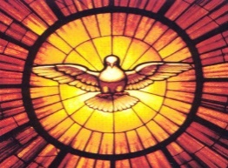
Congratulations to all the pupils of Cahermore National School, who received the Sacrament of Confirmation this week. May they be filled with the Holy Spirit.
This Photo by Unknown Author is licensed under CC BY-SA

Please Get INVOLVED: Following on from our Parish Gathering many people feel it is vital that we have some more people taking part in our church liturgies & groups. Therefore, we are hoping for some people to come forward who are willing to help. Please contact Claire. 0868344354

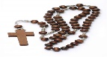
There will be rosary at the Grotto at Cahermore Church every Monday, Wednesday & Friday at 7.30pm for the month of May.
This Photo by Unknown Author is licensed under CC BY

CHY3 Form: Thank you to everyone who has returned the CHY3 forms. If any of you still have the forms, can you please return them as soon as possible.

Rally of the lakes: The rally of the Lakes will pass through the parish on Saturday 04th May, the Cods Head Stage. Here are the Road Closures from The Cross House to Urhan (known locally as “The High Road”) SS3 09.40am to 13.05pm and SS6 13.20pm to 16.40.
This Photo by Unknown Author is licensed under CC BY-NC-ND

Please come and support Beara's Got Talent, community concert in The Sacred Heart Church, Castletownbere at 7.30 pm on Sunday May 19th. Choir singing/Beara Singers/Barrettes/Traditional music/ Storytelling/ Piano music. Donations in aid of Cancer Connect.
Castletownbere Youth Theatre presents: ‘A Show about the conundrums of Climate Justice & Sustainability’ May 12th @3pm. Tickets at the door, Scoil an Chroí ro Naofa, Castletownbere
Cursillo walk: Cork to Knock route Tue July 16th - 21st. Approx 23 miles (37kms) per day. Mass daily, rosary, divine mercy chaplet & fellowship each day. Contact corktoknock@gmail.com to sign up for the full walk, a day, or a stage.
Walks also leaving from Dublin, Belfast & Derry: all converging to arrive in Knock.
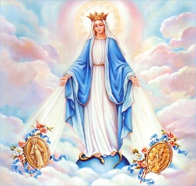
Reflection: A quote from Pope Francis: "The heart of Mary, more than any other, is a humble heart, capable of accepting God's gifts. In order to become man, God chose precisely her, a simple young woman of Nazareth, who did not dwell in the palaces of power and wealth, who did not do extraordinary things.

