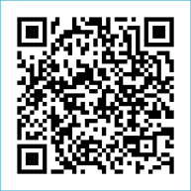
Scan to Donate

ST MARY’S PARISH NEWSLETTER - TARBERT
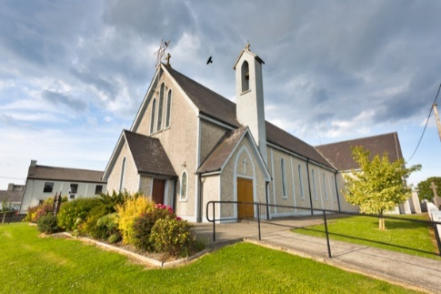
Parish Office Opening Hours:
Mon. 10.30am -2.30pm. Wed. 10.30am-1.30pm Priests :
Fri. 10.30am-2.30pm Phone ; 068-36111. Fr. Sean Hanafin 087-8341083

Email: tarbert@dioceseofkerry.ie Fr. Michael Hussey 087-2386084
Notices for Parish Newsletter have to be in on Safeguarding Children: 087-6362780 Wednesday by 12 Noon. Defib. Emergency No. 999 or 112
Webpage: www.stmarystarbert.com (Outside Surgery Hours)

The Ascension of the Lord
Sunday 12th May 2024

R.I.P. Michael J Coolahan, Main St. / Doonard. Kathleen Brosnan (née Hannon), Ballybunion.
Day/Date | Time | Intention
Saturday 11th | 11am  6pm | First Holy Communion.  Josie Finucane née Lyndon), ( Months Mind )  Rochester / Kilpadogue.
Sunday 12th | 11.30am | Seán, Bridget and Michael Ahern, Tarmons East.
Monday 13th | 9.30am | Mass in Tarbert.  Ellie and Mary Finucane, Doonard Lower.
Tuesday 14th | 7pm | Mass in Ballylongford.
Wednesday 15th | _____ | No Mass.
Thursday 16th | 10am | Mass in Asdee.
Friday 17th | 7pm | Mass in Tarbert.  Special Intention.
Saturday 18th | 6pm | Maureen Cregan, Tieraclea. ( 1st Anniversary )
Sunday 19th | 11.30am | Mass will be held in the Comprehensive School. (PE Hall)
PRIEST ON DUTY THIS WEEKEND: Fr. Seán Hanafin 087-8341083.
PARISH OFFERTORY COLLECTION Amount received will be published at the end of each month.
DIOCESAN COLLECTION - for the Education of Clergy will be held this weekend Sat. 11th / Sun. 12th May. You can use one of the Special Collection envelopes for it.
MASS TO BE MOVED – The 11.30am Mass on next Sunday 19th May will now be held in the P.E. hall in the Comprehensive School to mark the school’s Golden Jubilee. It’s a great opportunity for the community to mark the schools 50th year. Refreshments will be available to everyone after the Mass, as well as a tour of the school.
LIVE SERVICES – All Masses are now being live streamed from our Church. Just go to the Church website – www.stmarystarbert.com and you can watch on your phone, tablet, computer or smart T.V. When you log in and see the picture of the Altar, just underneath this, click on the mute button and you will then have the audio as well.
Prayer of St. Brendan the Navigator
( Feast Day, 16th May )

Help me to journey beyond the familiar and into the unknown.
Give me the faith to leave old ways and break fresh ground with You.
Christ of the mysteries,
I trust You to be stronger than each storm within me.
I will trust in the darkness and know that my times,
even now, are in Your hand.
Tune my spirit to the music of heaven and somehow,
make my obedience count for You. Amen.

TARBERT ACTIVE RETIREMENT GROUP – (over 55’s) meet in Tarbert Bridewell every Friday between 10.30am and 12 Noon. We have different activities every week followed by refreshments. New Members are welcome.
THANK YOU – The organisers of the recent poker classic in aid of the Tarbert Comprehensive Ladies Teams wish to thank all those that played and donated. The amount raised was € 745.
TARBERT BRIDEWELL - would like to thank everyone for their support with the coffee morning in aid of Recovery Haven which raised € 900.
SHARING GOOD NEWS’ EZINE - The Catholic Communications Office, Maynooth produces a five-story weekly ezine Sharing Good News that reports on stories associated with the Bishops' Conference,activities in parishes and dioceses, and that celebrates Church life generally. If you wish to subscribe to receive Sharing Good News please register your email address on: https://catholicnews.ie/newsletter/

DEMENTIA INCLUSIVE LISTOWEL - are holding a Memory Wellness & Dementia Awareness Event in The Listowel Arms Hotel at 6.30pm - 9pm on Thursday, 16th May. This is a free event to promote the importance of memory wellness and will include an input from Consultant Neurologist Dr. Antoinette O’Connor from Tallaght University Hospital, her research has focused on investigating accessible biomarkers of Alzheimer’s disease, with a particular focus on early disease detection. This will be followed by a panel discussion consisting of Dementia advisors, Geriatrician from UHK, Kerry Memory Technology Resource Room, the Fuchsia Centre and more. There will also be some information Stands open at 6.30pm. Places are limited, so booking is essential.

DIOCESAN EUCHARISTIC ADORATION REMINDER - Retreat this year at Our Lady's and St Brendan's Tralee on Friday 31st May. Presenters : Fr. Jim Lenihan / Deacon Thady O'Connor and Mass Celebrant Bishop Ray. See poster on notice board for details. Bookings - Margaret 087-2976304: Breda 087-6742306.

THANK YOU - for your continuing support and financial donations that underpin the smooth running of St. Mary’s Parish Church. Please continue to donate what you can on a weekly basis at any of our Masses on Friday, Saturday, Sunday or Monday. Donations can also be made by bank transfer – our bank details are as follows :
IBAN No- IE76 AIBK 9354 3380 3050 83, Account Name – Tarbert Church Account,
Bank - AIB, The Square, Listowel Co. Kerry.
Thanking you on behalf of the Finance Committee,
John McMonagle (Chairperson), Fr. Sean Hanafin, Mary Holland, Kitty Kelly, Amanda O’Sullivan,
Seamus Enright, Declan Downey, Gabriel McNamara.

