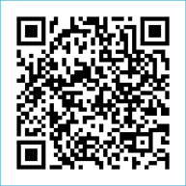
Scan to Donate

ST MARY’S PARISH NEWSLETTER - TARBERT
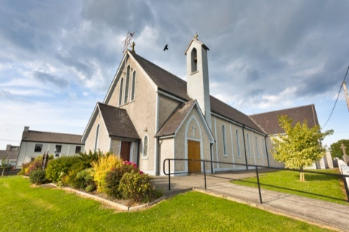
Parish Office Opening Hours:
Mon. 10.30am -2.30pm. Wed. 10.30am-1.30pm Priests :
Fri. 10.30am-2.30pm Phone ; 068-36111. Fr. Sean Hanafin 087-8341083

Email: tarbert@dioceseofkerry.ie Fr. Michael Hussey 087-2386084
Notices for Parish Newsletter have to be in on Safeguarding Children: 087-6362780 Wednesday by 12 Noon. Defib. Emergency No. 999 or 112
Webpage: www.stmarystarbert.com (Outside Surgery Hours)

The Most Holy Body and Blood of Christ
Sunday 2nd June 2024

Day/Date | Time | Intention
Saturday 1st | 6pm | Fr. Tommy O’ Hanlon, Dooncaha.  Annie, Tom, Margaret, Thomas and Michael O’ Hanlon,  St. Patrick’s Tce.
Sunday 2nd | 11.30am | Fr. John, ( Ordination Anniversary Mass )  Paddy and Seamus Griffin, Shanaway.
Monday 3rd | _____ | No Mass.
Tuesday 4th | 7pm | Mass in Ballylongford.
Wednesday 5th | _____ | No Mass.
Thursday 6th | 10am | Mass in Asdee.
Friday 7th | 7pm | Mass in Tarbert.  Kathleen Fitzgerald, Foynes.
Saturday 8th | 6pm | Bertie Costelloe, Doonard Crescent.
Sunday 9th | 11.30am | Michael J. Coolahan, Main St. ( Months Mind )  John (Johnny) Coolahan, Dublin / Main St.  John Downey, The Square.  Mary Hennessy and Marie McCarthy, Main St.
PRIEST ON DUTY THIS WEEKEND: Fr. Declan O’ Connor 087-0908949.
PARISH OFFERTORY COLLECTION May - € 3,507 Maintenance Fund - € 480 Online Banking - € 154.22
Easter Garden - € 115 Diocesan Collection - € 238 Míle Buíochas.
DIOCESAN COLLECTION – A second collection will be taken up for Family Services / Accord this weekend Sat. 1st / 2nd June.
THE NOVENA TO THE SACRED HEART – began on Wednesday 29th May and continues until Thursday 6th June.
LIVE SERVICES – All Masses are now being live streamed from our Church. Just go to the Church website – www.stmarystarbert.com and you can watch on your phone, tablet, computer or smart T.V. When you log in and see the picture of the Altar, just underneath this, click on the mute button and you will then have the audio as well.
Novena Prayer

Lord Jesus Christ your heart was moved with love for those who sought You.
You healed the sick, fed the hungry and forgave sinners.
You showed to those who would listen the way to true life,
for You are the Way, the Truth and the Life.
Your heart is still moved today by your people and their needs.
Open my heart to hear your word, to accept your love and to respond to your call.
In particular, I beg you to grant me the favour that I ask
during this Novena, (make your request silently)
provided that it will contribute to my own eternal good
and to the building up of your Kingdom of love, peace and justice here on earth.
Most Sacred Heart of Jesus, I place all my trust in You.

Exam Prayer
Dear Lord, as I take these exams,
I thank you that my life is
enfolded in the embrace on
Your great love for me.
Help me with all the testing
challenges of life that will
come my way.

Holy Spirit, guide me with the
gifts of Wisdom, Knowledge,
Understanding and right Judgement.

Holy Mary, pray for us
and all our young people.
May they know the touch of
your loving caress. Amen.

TARBERT ACTIVE RETIREMENT GROUP – (over 55’s) meet in Tarbert Bridewell every Friday between 10.30am and 12 Noon. We have different activities every week followed by refreshments. New Members are welcome.
BINGO – will be on next Wed. 5th June at 8pm in the Community Centre – with bigger and better prize money. Your support would be greatly appreciated. All are welcome.

THANK YOU - for your continuing support and financial donations that underpin the smooth running of St. Mary’s Parish Church. Please continue to donate what you can on a weekly basis at any of our Masses on Friday, Saturday, Sunday or Monday. Donations can also be made by bank transfer – our bank details are as follows :
IBAN No- IE76 AIBK 9354 3380 3050 83, Account Name – Tarbert Church Account,
Bank - AIB, The Square, Listowel Co. Kerry.
Thanking you on behalf of the Finance Committee,
John McMonagle (Chairperson), Fr. Sean Hanafin, Mary Holland, Kitty Kelly, Amanda O’Sullivan,
Seamus Enright, Declan Downey, Gabriel McNamara.

