Scan to Donate

ST MARY’S PARISH NEWSLETTER - TARBERT
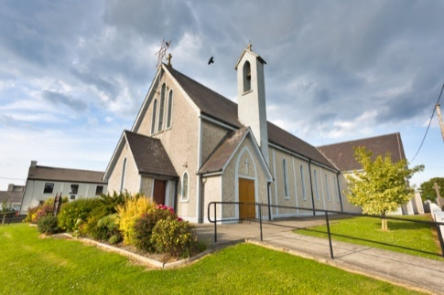
Parish Office Opening Hours:
Mon. 10.30am -2.30pm. Wed. 10.30am-1.30pm Priests :
Fri. 10.30am-2.30pm Phone ; 068-36111. Fr. Sean Hanafin 087-8341083

Email: tarbert@dioceseofkerry.ie Fr. Michael Hussey 087-2386084
Notices for Parish Newsletter have to be in on Safeguarding Children: 087-6362780 Wednesday by 12 Noon. Defib. Emergency No. 999 or 112
Webpage: www.stmarystarbert.com (Outside Surgery Hours)

12th Sunday in Ordinary Time
23RD June 2024

Day/Date | Time | Intention
Saturday 22nd | 11am  6pm | Funeral Mass for Alex Langan, Tarbert Island.  Thanksgiving Mass –  for Kitty’s 100 years of life.
Sunday 23rd | 11.30am | James Murphy, Church St.
Monday 24th | 10am | Mass in Tarbert.  Private Intention.
Tuesday 25th | 7pm | Mass in Ballylongford.
Wednesday 26th | _____ | No Mass.
Thursday 27th | 10am | Mass in Asdee.
Friday 28th | 7pm | Mass in Tarbert.  Special Intention.
Saturday 29th | 6pm | Deceased Clergy of Tarbert.
Sunday 30th | 11.30am | John Joe and Peggy Barrett, Tarmons.  Nancy and Jimmy Enright, Tieraclea.

PRIEST ON DUTY THIS WEEKEND: Fr. Brendan Walsh 087-7913271.
PARISH OFFERTORY COLLECTION Amount received will be published at the end of each month.
GRAVEYARD MASSES – Aghavallen Cemetery – Friday 5th July at 7pm. Lislaughtin Abbey – Friday 2nd August at 7pm. Kilnaughtin Graveyard – Friday 9th August at 7pm. St. Mary’s Cemetery, Tarbert – Friday 16th August at 7pm. Please note that all Graveyard Masses are at 7pm.

All our Masses at St. Mary’s Church, Tarbert,
can be viewed online at www.stmarystarbert.com

The Stream of Life

Life could be compared to a stream.
In its journey to the sea
a stream cannot always advance by the shortest route,
but has to twist and turn,
and pause a while here and there,
without ever coming to a complete stop.
And yet in spite of all this dallying,
in spite of all these detours,
how quickly life’s stream runs down to the sea.
Lord, may your gentle hand guide us,
so that in spite of doubts, difficulties and dangers,
we may keep the stream of our lives
flowing towards your kingdom.

100TH BIRTHDAY CELEBRATIONS - The family of Kitty Griffin cordially invite you to join with them in celebrating her milestone, 100th birthday in the Community Centre on next Wednesday 26th June from 7 pm to 9 p.m. Light refreshments will be provided.
TARBERT ACTIVE RETIREMENT GROUP – (over 55’s) meet in Tarbert Bridewell every Friday between 10.30am and 12 Noon. We have different activities every week followed by refreshments. New Members are welcome.
ANNUAL PILGRIMAGE TO KNOCK - takes place this year on Wed. 3rd July. The coach will be leaving Listowel at 7am, Knockanure at 7.10am Moyvane at 7.15am and Tarbert at 7.20am. Contact Margaret on 087-2976304 or Nuala on 068-36166. More details later.
ARD CÚRAM & FUCHSIA CENTRE – AIB Community €1M Fund, Vote for us. The AIB Community €1M Fund is now open. This is an opportunity for charities like Ard Chúram, Listowel, to be in with a chance of receiving funds but we need as many people as possible to VOTE for us. To find out more check out online www.ardcuram.com
Designer Minds - STEAM (Science, Technology, Engineering, Art, Maths) Summer Camps and Art Summer Camps will start soon in Listowel. For all boys & girls going into 1st to 6th class this September. All details and online registration at www.designerminds.ie. Give your child the opportunity to explore, create, innovate and learn in a fun and supportive environment this Summer.

THANK YOU - for your continuing support and financial donations that underpin the smooth running of St. Mary’s Parish Church. Please continue to donate what you can on a weekly basis at any of our Masses on Friday, Saturday, Sunday or Monday. Donations can also be made by bank transfer – our bank details are as follows :
IBAN No- IE76 AIBK 9354 3380 3050 83, Account Name – Tarbert Church Account,
Bank - AIB, The Square, Listowel Co. Kerry.
Thanking you on behalf of the Finance Committee,
John McMonagle (Chairperson), Fr. Seán Hanafin, Mary Holland, Kitty Kelly, Amanda O’Sullivan,
Seamus Enright, Declan Downey, Gabriel McNamara, Paul Kelly.

