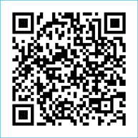
Scan to Donate

ST MARY’S PARISH NEWSLETTER - TARBERT
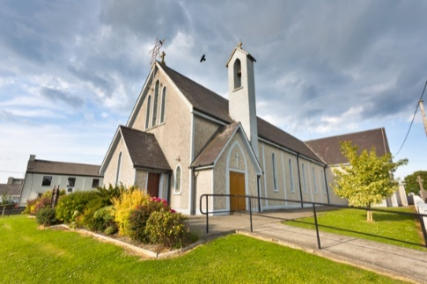
Parish Office Opening Hours:
Mon. 10.30am -2.30pm. Wed. 10.30am-1.30pm Priests :
Fri. 10.30am-2.30pm Phone ; 068-36111. Fr. Sean Hanafin 087-8341083

Email: tarbert@dioceseofkerry.ie Fr. Michael Hussey 087-2386084
Notices for Parish Newsletter have to be in on Safeguarding Children: 087-6362780 Wednesday by 12 Noon. Defib. Emergency No. 999 or 112
Webpage: www.stmarystarbert.com (Outside Surgery Hours)

Tenth Sunday in Ordinary Time
9th June 2024
Day/Date | Time | Intention
Saturday 8th | 6pm | Bertie Costelloe, Doonard Crescent.
Sunday 9th | 11.30am | Michael J. Coolahan, Main St. ( Months Mind )  John (Johnny) Coolahan, Dublin / MainSt.  John Downey, The Square.  Mary Hennessy and Marie McCarthy, Main St.
Monday 10th | 10am | Mass in Tarbert.  Tadgh and Liam Foley, Doonard Lower / Tieraclea.
Tuesday 11th | 7pm | Mass in Ballylongford.
Wednesday 12th | _____ | No Mass.
Thursday 13th | 10am | Mass in Asdee.
Friday 14th | 7pm | Mass in Tarbert.  Special Intention.
Saturday 15th | 6pm | People of the Parish.
Sunday 16th | 11.30am | Deceased O’ Connell Family Members, Dooncaha.

CONGRATULATIONS FR. SEÁN

The priests and the people of the parish of Tarbert would like to congratulate Fr. Seán on his Golden Jubilee
( 50 years a priest ) and wish him health and happiness for many more years to come.
May the Lord continue to shower you with his blessings.

PRIEST ON DUTY THIS WEEKEND: Fr. Liam O’ Connor 086-8288719.
PARISH OFFERTORY COLLECTION Amount received will be published at the end of each month.
GOLDEN JUBILEE – Fr. Seán Hanafin will celebrate his Golden Jubilee ( 50 years as a priest ) on Sunday 9th June. A special Golden Jubilee Mass for Fr. Seán will be celebrated in Ballybunion on Sunday June 23rd. After Mass, refreshments will be served in the school next door. Everyone welcome to attend.

THE BEAUTIFUL HANDS OF A PRIEST

We need them in life's early morning,
We need them again at its close;
We feel their warm clasp of true friendship,
We seek them when tasting life's woes.
At the altar each day we behold them,
And the hands of a king on his throne
Are not equal to them in their greatness;
Their dignity stands all alone;
And when we are tempted and wander,
To pathways of shame and sin,
It's the hand of a priest that will absolve us --
Not once, but again and again;
And when we are taking life's partner,
Other hands may prepare us a feast,
But the hand that will bless and unite us --
Is the beautiful hand of a priest.
God bless them and keep them all holy
For the Host which their fingers caress;
When can a poor sinner do better,
Than to ask Him to guide thee and bless?
When the hour of death comes upon us,
May our courage and strength be increased,
By seeing raised over us in blessing --
The beautiful hands of a priest! Author Unknown

TARBERT ACTIVE RETIREMENT GROUP – (over 55’s) meet in Tarbert Bridewell every Friday between 10.30am and 12 Noon. We have different activities every week followed by refreshments. New Members are welcome.
TARBERT COMMUNITY CENTRE – are holding their A.G.M. on this Monday 10th June at 8pm in the Community Centre. All are welcome.
NATIONAL CARERS WEEK - Mass will be offered up for all carers and for the people they care for on this Monday 10th June the 10.30am in St. Mary’s Church, Listowel – it’s especially those living in Listowel and North Kerry area.
ANNUAL PILGRIMAGE TO KNOCK - takes place this year on Wed. 3rd July. The coach will be leaving Listowel at 7am, Knockanure at 7.10am Moyvane at 7.15am and Tarbert at 7.20am. Contact Margaret on 087-2976304 or Nuala on 068-36166. More details later.
THANK YOU - for your continuing support and financial donations that underpin the smooth running of St. Mary’s Parish Church. Please continue to donate what you can on a weekly basis at any of our Masses on Friday, Saturday, Sunday or Monday. Donations can also be made by bank transfer – our bank details are as follows :
IBAN No- IE76 AIBK 9354 3380 3050 83, Account Name – Tarbert Church Account,
Bank - AIB, The Square, Listowel Co. Kerry.
Thanking you on behalf of the Finance Committee,
John McMonagle (Chairperson), Fr. Sean Hanafin, Mary Holland, Kitty Kelly, Amanda O’Sullivan,
Seamus Enright, Declan Downey, Gabriel McNamara.

