Scan to Donate

ST MARY’S PARISH NEWSLETTER - TARBERT
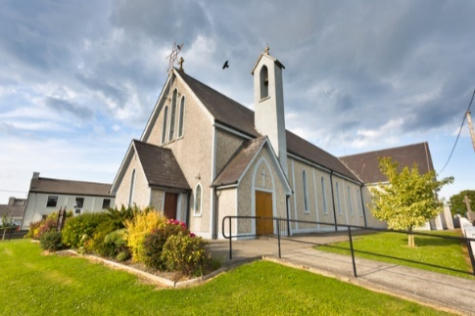
Parish Office Opening Hours:
Mon. 10.30am -2.30pm. Wed. 10.30am-1.30pm Priests :
Fri. 10.30am-2.30pm Phone ; 068-36111. Fr. Sean Hanafin 087-8341083

Email: tarbert@dioceseofkerry.ie Fr. Michael Hussey 087-2386084
Notices for Parish Newsletter have to be in on Safeguarding Children: 087-6362780 Wednesday by 12 Noon. Defib. Emergency No. 999 or 112
Webpage: www.stmarystarbert.com (Outside Surgery Hours)

Tenth Sunday in Ordinary Time
9th June 2024

Day/Date | Time | Intention
Saturday 8th | 6pm | Bertie Costelloe, Doonard Crescent.
Sunday 9th | 11.30am | Michael J. Coolahan, Main St. ( Months Mind )  John (Johnny) Coolahan, Dublin / MainSt.  John Downey, The Square.  Mary Hennessy and Marie McCarthy, Main St.
Monday 10th | 10am | Mass in Tarbert.  Tadgh and Liam Foley, Doonard Lower / Tieraclea.
Tuesday 11th | 7pm | Mass in Ballylongford.
Wednesday 12th | _____ | No Mass.
Thursday 13th | 10am | Mass in Asdee.
Friday 14th | 7pm | Mass in Tarbert.  Special Intention.
Saturday 15th | 6pm | People of the Parish.
Sunday 16th | 11.30am | Deceased O’ Connell Family Members, Dooncaha.
PRIEST ON DUTY THIS WEEKEND: Fr. Liam O’ Connor 086-8288719.
PARISH OFFERTORY COLLECTION Amount received will be published at the end of each month.
LIVE SERVICES – All Masses are now being live streamed from our Church. Just go to the Church website – www.stmarystarbert.com and you can watch on your phone, tablet, computer or smart T.V. When you log in and see the picture of the Altar, just underneath this, click on the mute button and you will then have the audio as well.

All our Masses at St. Mary’s Church, Tarbert,
can be viewed online at www.stmarystarbert.com
Exam Prayer

Dear Lord, as I take these exams,
I thank you that my life is
enfolded in the embrace on
Your great love for me.
Help me with all the testing
challenges of life that will
come my way.

Holy Spirit, guide me with the
gifts of Wisdom, Knowledge,
Understanding and right Judgement.

Holy Mary, pray for us
and all our young people.
May they know the touch of
your loving caress. Amen.

TARBERT ACTIVE RETIREMENT GROUP – (over 55’s) meet in Tarbert Bridewell every Friday between 10.30am and 12 Noon. We have different activities every week followed by refreshments. New Members are welcome.
TARBERT COMMUNITY CENTRE – are holding their A.G.M. on this Monday 10th June at 8pm in the Community Centre. All are welcome.
NATIONAL CARERS WEEK - Mass will be offered up for all carers and for the people they care for on this Monday 10th June the 10.30am in St. Mary’s Church, Listowel – it’s especially those living in Listowel and North Kerry area.
ANNUAL PILGRIMAGE TO KNOCK - takes place this year on Wed. 3rd July. The coach will be leaving Listowel at 7am, Knockanure at 7.10am Moyvane at 7.15am and Tarbert at 7.20am. Contact Margaret on 087-2976304 or Nuala on 068-36166. More details later.

THANK YOU - for your continuing support and financial donations that underpin the smooth running of St. Mary’s Parish Church. Please continue to donate what you can on a weekly basis at any of our Masses on Friday, Saturday, Sunday or Monday. Donations can also be made by bank transfer – our bank details are as follows :
IBAN No- IE76 AIBK 9354 3380 3050 83, Account Name – Tarbert Church Account,
Bank - AIB, The Square, Listowel Co. Kerry.
Thanking you on behalf of the Finance Committee,
John McMonagle (Chairperson), Fr. Sean Hanafin, Mary Holland, Kitty Kelly, Amanda O’Sullivan,
Seamus Enright, Declan Downey, Gabriel McNamara.

