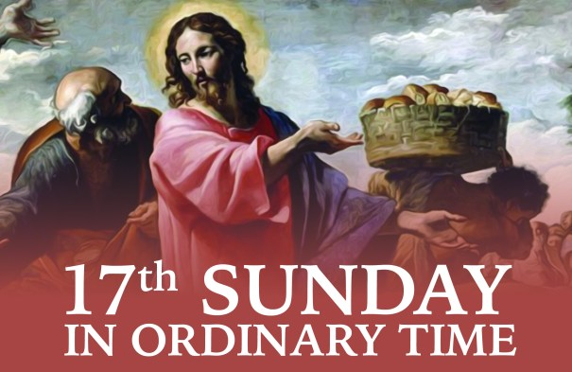

All the accounts of the first Eucharist show Jesus taking bread, blessing it and sharing it with others. Today’s gospel on the multiplication of the loaves and fish uses these same words to describe what Jesus did on that occasion.

***This weekend’s response to the Responsorial Psalm is:***

***You open wide your hand , O Lord,***

***And grant our desires.***

|  |  |  |
| --- | --- | --- |
| **17th Sunday in Ordinary Time 28/07/2024** | | |
| Please pray for Concepta (Connie) O’Connor (née Carmody), Milleen; Micheal O’Donoghue, Gneeveguilla; Ellen (Eileen) Cronin, Gneeveguilla. Joan Corkery (née Horgan), Killarney. May they rest in peace. | | |
| Priest on duty this weekend: Fr. Kieran O’Brien 064 6631014/ 087 6501998 (for emergencies only). | | |
| **Masses for the coming week** | | |
| **Sat 27th July** | **7.30pm** | Angela O’Connor (1st Anniv) R.I.P. Inch |
| **Sun 28th July** | **11.30am** | John Doyle R.I.P. Rathanane |
| **Tues 30th July** | **9.30am**  **10-6pm** | Special Intention  Adoration |
| **Fri 2nd August**  **(First Friday)** | **7.00pm**  **7.30pm** | Rosary & Benediction  Deceased family Mass R.I.P. |
| **Sat 3rd August** | **7.30pm** | Danny Healy R.I.P. Kilcummin P.O.  Johnny Brosnan R.I.P. Knockmanaugh  Tom & Sheamus Fleming R.I.P. and deceased family members of the O’Connor family of Glounonea & Canada |
| **Sun 4th August** | **11.30am** | Mary & John Devane R.I.P. Mastergeeha |

|  |  |  |  |
| --- | --- | --- | --- |
| **3rd & 4th**   **August** | **Readers** | **Eucharistic Ministers** | **Altar Servers** |
| **Vigil 7.30pm** | J.Casey | E.Walsh  P.Healy | E.K.Pigott D.Fleming  A.McSweeney L.O’Sullivan |
| **Sun 11.30am** | E.Fleming | K.O’Donoghue  N.Fleming | A.M.O’Sullivan C.Blake  M.O’Sullivan I.Condon |

**Offertory Collection:** €1,192.00. Míle Buíochas. Please note, envelopes for sick and retired priests can still be handed in at weekend masses, total to date €1,417.00. Míle Buíochas.

**Second Collection** will take place next weekend on the 3rd & 4th August on behalf of the Pastoral and Retreat Centres. The John Paul II Pastoral Centre in Killarney act as a focal point for the catechetical and faith education programmes for the diocese while the Ardfert Retreat Centre provides the opportunity to take time apart and reflect on God’s call to all people of our diocese in a peaceful and prayerful environment.

**Parish Office:** Open: Tues, Wed & Fri 10.00am – 12 noon. Tel: 064

6643176 / Mobile: 087 1339732, e-mail [kilcummin@dioceseofkerry.ie](mailto:kilcummin@dioceseofkerry.ie)

**Church Collectors Rota for August**: **Saturdays 7.30pm:** T. Sugrue &

H. Kerins. **Sundays 11.30am**: T. Brosnan & J. Moriarty.

**Best Wishes:** We would like to welcome Fr. Vitalis to the Pastoral Team wishing him good luck and happiness in his new ministry.

**Celebration of Significant Wedding Anniversaries:** A word of appreciation and thanks to all those who were involved in the setting up and in the organisation of the celebration of significant anniversaries of  marriage vows at last Saturday evening Mass: it was truly a powerful event as evident in the numbers attending from 25 years to 55 years of marriage together. First a special thanks to Siobhan and team for their efficiency in coordinating the event. Thank you also to Fr Kieran for his eloquent words on marriage which he shared with us in the Mass and for joining the couples for tea and cakes afterwards. The Altar was beautifully set up with a banner and flowers which set the scene for marking the occasion also giving Geraldine our photographer an opportunity to capture the moment. Thank you to all those who put their mark on the banner. The music and hymns wonderfully reflected the occasion, to Mick from the Rural Development who prepared the hall, The celebration would have been incomplete without the work of the “Kilcummin parish bakers” with their array of different homemade cakes and sandwiches. Evidence of appreciation was acknowledged by the numbers in the community who attended the banquet and the cutting of the luxurious Wedding Cake. Míle Buiochas on behalf of all.

**Communal First Saturday** **Devotions** will take place on the 3rd August @ 8.45am in the Church of the Resurrection, Killarney. Devotions will begin with the Fatima Intentions followed by the Rosary and the celebration of Mass @ 9.30am.

**Upcoming Cemetery Masses** will be celebrated in the following grounds.

Aghadoe Cemetery Mass: Monday 29th July, @ 8pm.

New Cemetery Mass: Monday 5th August @ 7pm.

Old Kilcummin Mass: Wednesday 7th August @ 7.30pm.

Please pass on these dates to family and friends.

**Kilcummin CCÉ**: Well done to all of our competitors in dancing, music and singing this past week at Fleadh Cheoil na Mumhan in Thurles. We very much appreciate all of your hard work and dedication, together with your families and mentors, to get to compete at Munster level. We congratulate those who have qualified for Fleadh Cheoil na hÉireann in Wexford next month and we wish you well in your preparations over the coming weeks. We have limited stock of branch leisurewear in adult sizes. All enquiries to Shane or Geraldine please.

**Save the Date:** Family Fun Day will take place on Monday 5th August in the Kilcummin GAA grounds. Get ready for a day of fun, games, and excitement. Free entry, all welcome. At 11am -1pm: U13 Preliminary Games; 1pm-4pm: Giant games, colouring competition; 1-2pm: Skills Competition, 2-3pm: Races, Tug of War; 3.30pm: Final of the U13 Parish League. There will be face painting, colouring corner, races from tiny tots to moms and dads and lots more, also club merchandise on sale, food by John Scully.

**My Daily Bread**

Heavenly Father, walk with me today,

and grant that I may hear Your footsteps

and gladly follow where they lead.

Talk with me today

and grant that I may hear your tender voice,

and quicken to its counsel.

Stay with me today

and grant that I may feel

your gentle presence in all I do and think.

Be my strength when I am weak,

my courage when I fear.

Help me to know that it is your hand

holding mine through all the hours of this day

and when night falls

grant that I may know

I rest in your Sacred Heart.