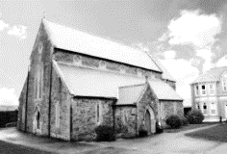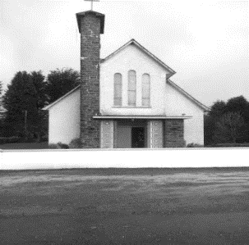

**DUAGH & LYREACROMPANE PARISH NEWSLETTER**

**TWENTY – FIRST SUNDAY IN ORDINARY TIME**

**25TH AUGUST 2024**

**Duagh Parish Office, The Presbytery, Tel: 068 45102.**

**Office Hours: Tuesday, Wednesday & Thursday 10.00am - 3.00pm. Email:** [**duagh@dioceseofkerry.ie**](mailto:duagh@dioceseofkerry.ie)

**Parish Moderator: Fr. Declan O’Connor 068 21188.**

**Fr. Jack O’Donnell: 0871027961.**

**MASSES IN ST BRIGID’S CHURCH DUAGH**

**Sunday 25th August @ 11:30 am**

Deceased members of the McElligott Family, Duagh Village and the UK

**Friday 30th August @ 7:30 pm**

Mai Hickey Knockalougha (*Months Mind*)

**MASSES IN SACRED HEART CHURCH LYREACROMPANE**

**Sunday 25th August @ 10:00 am**

Patrick Canty Lyre (*1st Anniversary Mass)*

Eileen Browne Murphy Abbeyfeale (*Anniversary Mass*)

Michael Costello Lyre (*Anniversary Mass*)

**PRIEST ON DUTY THIS WEEKEND:**

Fr Pat Crean-Lynch 087-2200114 (*Emergency number only*)

**CHURCH NOTICES**

**BOOKING OF MASSES / BAPTISMS / MARRIAGES /CERTS/ ETC FOR THE PARISH:** You may do them in two ways: Book directly with the Parish Office during Office hours on Tuesday, Wednesday & Thursday from 10.00 a.m. to 3.00 p.m. Alternatively, book online by sending an email to: [duagh@dioceseofkerry.ie](mailto:duagh@dioceseofkerry.ie) and the Parish Office will be in touch with you.

**ADORATION OF THE BLESSED SACRAMENT**: takes place each Friday in Duagh Church from 3.00 p.m. in the afternoon. Public Rosary starts at 7.00 p.m. Mass starts at 7:30 p.m.

**MONTHLY FATIMA ROSARY**: will be held at Lacca Cross Grotto on the 13th of every month from June to October @ 8.15pm. All Welcome.

**SAINT BERNADETTE RELIC PILGRIMAGE 2024**: Be part of the St Bernadette Relic Pilgrimage in Ireland. In 1858, Our Blessed Lady appeared 18 times to a young girl, Bernadette Soubirous in Lourdes. Bernadette died in 1879 and was later canonized in 1933. Her relics will journey on pilgrimage to Ireland for the first time, from September 4th to November 5th, taking in every diocese in the country. In Kerry, Our Lady & St Brendan’s Church, Tralee will be where the relics can be venerated on Friday September 13th and Saturday September 14th. More details to follow.

**COMMUNITY NEWS**

**COMMUNITY CHOIR**: The North Kerry Community Choir is resuming on Monday September 2nd at 1pm in St Patrick’s Hall, Upper William Street, Listowel. New Members very welcome. E40 per 5-week term. Under the direction of Award-Winning Singer/ Songwriter Mary Culloty O’ Sullivan. Phone: 0879222753

**BEST WISHES TO ALL OUR STUDENTS**: from Duagh and Lyre Parish, as they return back to school this coming week. A special mention to our little infants who will start school for the first time. As you step into a new year of learning, remember that each day is a fresh opportunity to grow, explore, and achieve great things. Embrace the challenges and celebrate the small wins. Your potential is limitless, and this year is your chance to shine.

**PARISH NEWSLETTER**: Should you wish to include a Notice for the Duagh & Lyre Parish Newsletter please contact the Parish Office before Wednesday, 12.00 noon before it goes to print. Phone 068 45102 or Email: [duagh@dioceseofkerry.ie](mailto:duagh@dioceseofkerry.ie). Thank You.