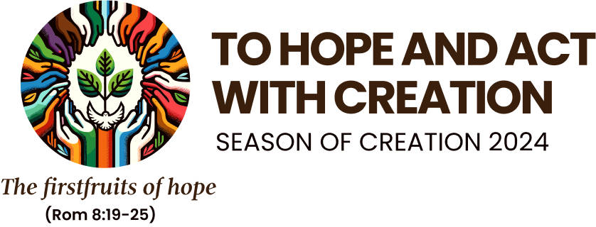



**“*Tráth an Chruthaithe”***

**1st September – 4th October**

***“Living our vocation to be protectors of God’s handiwork is essential to a life of virtue; it is not an optional or secondary aspect of our Christian experience.”*** Laudato Si’ #217

***Irish Bishops’ Spring Statement, 8 March, 2023***

“In response to the impending loss of nature to our world, the call of Pope Francis’ 2015 encyclical letter, Laudato Si’ (LS) and agreements made at the UN Conference on Biodiversity (COP15), bishops **ask parishes,** through their parish pastoral councils and diocesan trusts, as a first step, **to identify and care for 30% of parish grounds** as a haven for pollinators and biodiversity that can be enjoyed in perpetuity by the whole community.”

**SO WHAT CAN WE DO IN OUR PARISHES?**

**Encourage** our parishes to set aside a part of the parish grounds/garden as a *‘a haven for pollinators and biodiversity*

* Invite your Parish Pastoral Councils to discuss and invite participation.
* A small group needs to come together in each parish including the caretaker/groundsman
* This group could visit another parish that is already taking steps in their grounds.
* Consider what support (s) your parish needs.
* Help may be close at hand e.g. someone in your parish, a local Tidy Towns group.
* There is help available (various resources/some funding):Co. Kerry- Biodiversity Officer: [eleanor.turner@kerryco.co.ie](mailto:eleanor.turner@kerryco.co.ie) and Co. Cork- Conor Nelligan, Heritage Officer 021 428590

**More Information**: Diocese of Kerry Justice, Peace and Integrity of Creation Committee (JPIC) see <https://www.dioceseofkerry.ie/justice/eco-award/season-of-creation-2024/>

Catholic Bishops Conference: <https://www.catholicbishops.ie/laudato-si/season-of-creation-2024/>

‘How to’ video - <https://vimeo.com/905125930?share=copy>

**Spending time** in nature, *“sa nadúr”,* listening, looking, feeling, 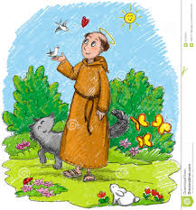can help us to know and appreciate God’s Book of Nature…