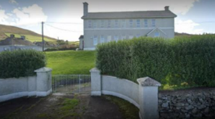**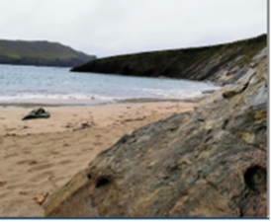An Margadh Is Fearr in Éirinn!**

**Saoire sa Ghaeltacht ar slad mhargadh**

**Cuir snas ar do chuíd Ghaoluínne.**

**Tá Brú na Gráige i gceart lár Gaeltacht Chiarraí, dhá mhíle déag siar ón nDaingean in aice le Dún Chaoin á chur ar chíos d’éinne atá sásta an Ghaeilge atá acu a labhairt laistigh den Bhrú agus timpeall na háite. I láthair na huaire tá slí do 24 duine sa Bhrú. Tá trá gainimh deich neomaid ón mBrú.**

**7 oíche (ó Sathairn go Satharn) I mí Dheireadh Fómhair, Samhain, Nollaig 2024 nó Eanáir 2025 ar €200**

## **Is féidir le duine singil an Brú a fháil ar chíos ar feadh seachhtaine ó Shathairn go Sathairn ar €200**

* **Is féidir le grúpaí ó 1-4 duine an Brú a fháil ar chíos ar feadh seachtaine ó Shathairn go Sathairn ar €200 in aghaidh na seachtaine**

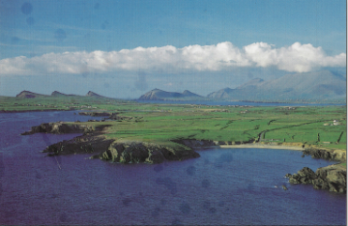

* **Deireadh Seachtaine - €200 do ghrúpaí 1-4 le híocaiocht breise de €25 an duine os cionn 4 daoine**
* **Is féidir le grúpaí níos mó (lena n- airítear teaghlaigh) ó 1-12 duine an Brú d’fáil ar chios ar feadh seachtaine ar €200 móide de €25 breise an duine os cionn 4 daoine go dtí uasmhéid de 12 duine**

**Tairiscint speisialta do Bhunscoileanna, Meánscoileanna agus Ollscoileanna**

**€8 an dalta in aghaidh na hoíche ar dhá 2 oíche**

**€10 an dalta ar oíche amháin**

***Gach eolas ó Pádraig Mac Stiopháin nó Tomás Ó Murchú***

***021 4771710/087 2903913***

* **Baineann rátaí speisialta le grúpaí níos mó ná 12 agus níos lú ná 24. Déan teagmháil dhíreach leis an Brú ar na huimhreacha thíos luaite**

**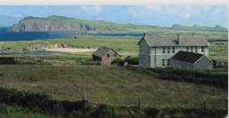*021***

***Gaeltacht Holidays – Best holiday bargain in Ireland***

Brú na Gráige in the heart of the Kerry Gaeltacht is available to rent to those willing to speak whatever Irish they know while in the Brú and in the Gaeltacht. It is situated in the heart of the Dingle Peninsula, 3 miles from Ballyferriter & 100 yards from Louis Mulcahy’s famous pottery.

**7-night stay (Saturday to Saturday) in October, November, December 2024 or January 2025 only €200**

## **A single person can rent the Brú for 1 week Sat-Sat for €200**

* **Special rates apply for groups larger than 12 and less than 24. Contact the Brú directly on the numbers below.**

**Special offer for Primary, Secondary and Colleges (Max Capacity of the Brú is 24)**

**€8 per student per night for 2-night stay**

**€10 per student for 1 night stay**

* **Larger groups of people (including families) from 1-12 people can rent the Brú for 1 week for €200 plus a surcharge of €25 per person above 4 persons to a max of 12 people**
* **Groups from 1-4 people can rent the Brú for 1 week Sat-Sat for €200 per week**
* **Weekends - €200 for groups of 1-4 with a surcharge of €25 per person above 4 persons.**

**This is a steal of a bargain!!! Best in Ireland**

*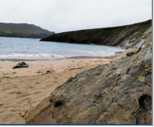****For Further information please contact: Pádraig Mac Stiopháin or Tomás Ó Murchú on 021 4771710 or mobile 087 2903913***

**The Brú can accommodate 24 people. Accommodation consists of single bunks and is self-catering. The Brú is only 5 mins from the sun-drenched, sandy beach of Clochair**